# BBN: Bayesian Belief Networks

**Intro**

Most of you may already be familiar with the Naive Bayes algorithm, a fast and simple modeling technique used in classification problems. While it is used widely due to its speed and relatively good performance, Naive Bayes is built on the assumption that all variables (model features) are independent, which in reality is often not true.

In some cases, you may want to build a model where you can specify which variables are dependent, independent, or **conditionally independent** (this is explained in the next section). You may also want to track real-time how event probabilities change as new evidence is introduced to the model.

This is where the **Bayesian Belief Networks** come in handy as they allow you to construct a model with nodes and directed edges by clearly outlining the relationships between variables.

# Bayesian Belief Networks (BBN) and Directed Acyclic Graphs (DAG)

Bayesian Belief Network (BBN) is a Probabilistic Graphical Model (PGM) that represents a set of variables and their conditional dependencies via a Directed Acyclic Graph (DAG).

To understand what this means, let’s draw a DAG and analyze the relationship between different nodes.

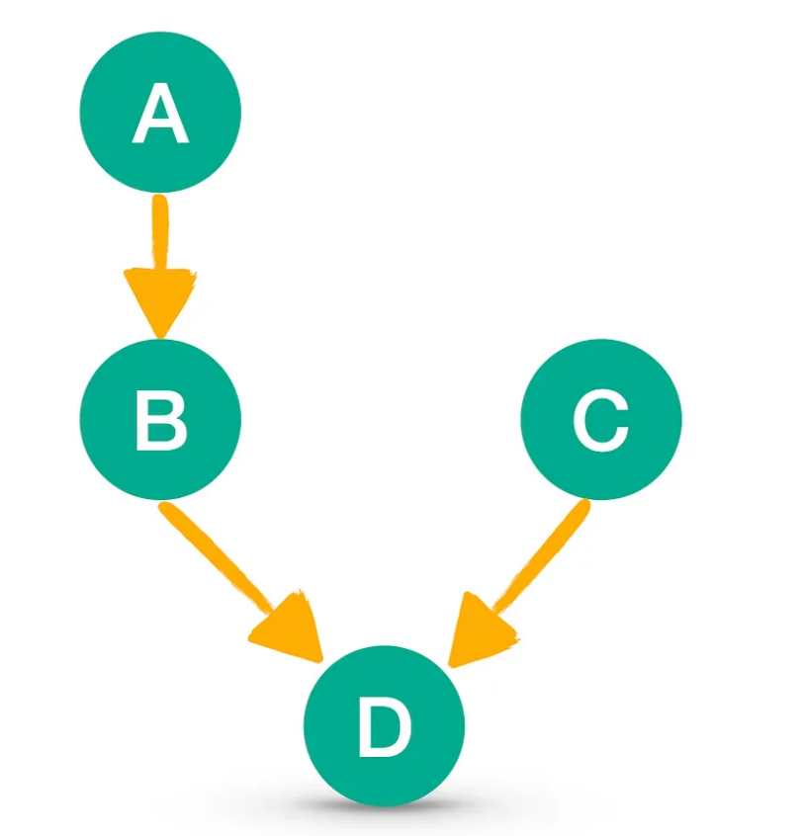

Using the above, we can state the relationship between variables (nodes):

* **Independence:** A and C are independent of each other. So are B and C. This is because knowing whether C has happened does not change our knowledge about A or B and vice versa.
* **Dependence:** B is dependent on A since A is the parent of B. This relationship can be written as a conditional probability: P(B|A). D is also dependent on other variables, and in this case, it depends on two of them — B and C. Again, this can be written as a conditional probability: P(D|B,C).
* **Conditional Independence:** D is considered conditionally independent of A. This is because as soon as we know whether event B has happened, A becomes irrelevant from the perspective of D. In other words, the following is true: P(D|B,A) = P(D|B).